**MMP 350 CSS Week 2 Class One**

**Table of contents**

Goals for Week 1

Review 1

Cascading Styles 1

Block, Inline and Inline-Block 2

Display None versus Visibility Hidden 2

Additional Reading, display:flex 2

Liquid and Fixed layouts 2

Exercise: Liquid Layout 3

Purpose 3

Steps 3

Step 3 3

Step 4 4

Step 5 4

Step 6 4

Step 7 5

Step 8 5

960 Pixel Templates 6

Critiquing a Site 6

Specific Topics (based on Tidwell Reading) 6

Additional Readings 6

4 Types of Grids and When Each Works Best 6

How to Choose The Right Grid 6

The Grid System 6

Wireframing 6

Layouts in CC, CS6 7

For Wednesday 7

## Goals for Week

* Review grid systems from the perspective of both design and coding
* Submit a one or two sentence description of your term project
* Book a time for presentation

## Review

### Cascading Styles

* When styles are inherited element styles (like <body>) takes precedence over class (like class=”body-text”), in the event of conflicts. A particular element can inherit attributes from multiple sources in multiple ways.
* When styles are applied directly to an element (as opposed to inherited from parents, grandparents etc) conflicts are resolved from the general to the specific, specifically from class to element to id

### Block, Inline and Inline-Block

See the example *inline_and_block_elements_review.html*

See <http://www.w3schools.com/cssref/pr_class_display.asp> for a discussion of the display property in general.

### Display None versus Visibility Hidden

Display: none removes the element from the document flow.

Visibility: hidden makes the element invisible, but continues to take up space in the program flow.

### Additional Reading, display:flex

<https://umaar.github.io/css-flexbox-demo/>

## Review: Margins and Padding

## Liquid and Fixed layouts

Fixed layouts are designed to fit precisely within the viewport of a device, for example a phone or tablet.

A fixed website layout has a wrapper that is a fixed width, and the components inside it have either percentage widths or fixed widths. The important thing is that the container (wrapper) element is set to not move. No matter what screen resolution the visitor has, he or she will see the same width as other visitors.”

<http://www.smashingmagazine.com/2009/06/fixed-vs-fluid-vs-elastic-layout-whats-the-right-one-for-you/>

Liquid layouts resize according to the dimensions of the viewport.

“All containers on the page have their widths defined in percents – meaning that they are completely based on the viewport rather than the initial containing block. A **liquid layout** will move in and out when you resize your browser window”

<http://maxdesign.com.au/articles/liquid/>

### Exercise: Liquid Layout

Based on the content at maxdesign.

### Purpose

Demonstrate basic principles of a liquid layout using a 3 column grid. This exercise should only take two or three minutes.

### Steps

1. Design your grid. The grid used in this exercise is as follows:

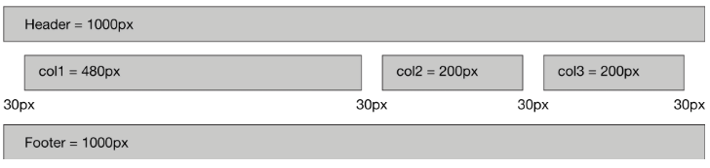

|  |  |  |
| --- | --- | --- |
| **Column** | **Width** | **Width in Percent** |
| Gutter 1 | 300 pixels | 3% |
| Column 1 | 480 pixels | 48% |
| Gutter 2 | 30 pixels | 3% |
| Column 2 | 200 pixels | 20% |
| Gutter 3 | 30 pixels | 3% |
| Column 3 | 200 pixels | 20% |
| Gutter 4 | 30 pixels | 3% |
| Total | 1000 pixels | 100% |

1. Translate this design into a table of style information. Use absolute values as a baseline, but then express these values as a percentage of the total.

*Note: when using percentages, it is important to leave a bit of extra space to handle rounding inconsistencies. This is one of the functions of gutter 1 and gutter 4.*

### Step 3

Create an HTML document called liquid_ex.html

<html>

<head>

<meta charset="utf-8">

<title>Positioning Example</title>

<link href="liquid.css" rel="stylesheet">

</head>

<body>

<div class="col1 lightgrey">

<span>Column One</span>

</div>

<div class="col2 cyan">

<span>Column Two</span>

</div>

<div class="col3 yellow">

<span>Column Three</span>

</div>

</body>

</html>

### Step 4

Create a CSS document called liquid.css

.col1,.col2,.col3

{

float: left;

margin-left: 3%;

}

.col1 { width: 48%; }

.col2 { width: 20%; }

.col3 { width: 20%; }

.lightgrey{background-color:salmon;}

.cyan{background-color:cyan;}

.yellow{background-color:yellow;}

### Step 5

View the document. It should look like this:

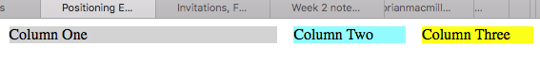

### Step 6

Update the html to include common elements:

<html>

<head>

<meta charset="utf-8">

<title>Positioning Example</title>

<link href="liquid.css" rel="stylesheet">

</head>

<body>

<div class="liquid_example">

<header class="header">

<span>Header</span>

</header>

<nav><span>Navigation</nav>

<div class="content">

<div class="col1 salmon">

<span>Column One</span>

</div>

<div class="col2 cyan">

<span>Column Two</span>

</div>

<div class="col3 yellow">

<span>Column Three</span>

</div>

</div>

<footer class="footer">Footer</footer>

</div>

</body>

</html>

### Step 7

Update the css to style the new elements

header

{

background-color: #ccc;

padding: 1em 2em;

margin-bottom: 1em;

}

nav

{

background-color: #ccc;

padding: 1em 2em;

margin-bottom: 1em;

}

footer

{

clear: both;

padding: 1em 2em;

background-color: #ccc;

}

.col1,.col2,.col3

{

float: left;

background-color: #eee;

margin-bottom: 1em;

margin-left: 3%;

}

.col1 { width: 48%; }

.col2 { width: 20%; }

.col3 { width: 20%; }

.salmon{background-color:lightgrey;}

.cyan{background-color:cyan;}

.yellow{background-color:yellow;}

### Step 8

View the results. They should look like the following:

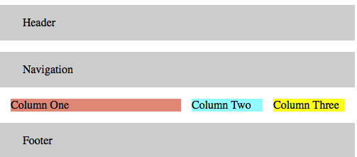

## 960 Pixel Templates

Discussion based on the article at <http://960.gs>

### Critiquing a Site

What are the issues when critiquing the design of a site?

1. Design: Look and Feel
   1. Example: csszengarden.com
2. Design: Usability
   1. Flow / navigation
   2. Ability to find things
   3. Functionality
3. Content

### Specific Topics (based on Tidwell Reading)

* Use of color
* Use of fonts
* Use of space
* Use of angles and curves
* Texture and rhythm
* Use of multi-media assets
* Use of visual motifs

## Additional Readings

### 4 Types of Grids and When Each Works Best

<http://vanseodesign.com/web-design/grid-types/>

### How to Choose The Right Grid

<http://vanseodesign.com/web-design/grid-choices/>

### The Grid System

http://www.thegridsystem.org

### Wireframing

https://www.wirify.com

### Layouts in CC, CS6

<https://helpx.adobe.com/indesign/using/alternate-layouts-liquid-layouts.html>

## For Wednesday

* Read Tidwell
* Write a one or two sentence description of what you would like to do for your class project and email me at [brianmacmillanteacher@gmail.com](mailto:brianmacmillanteacher@gmail.com) with your idea.
* Think about what website you would like to critique to the class. The website should be related to your term project. It can be a positive example – something that inspires you – or a negative example, or a bit of both.